- Introduction :
Test Data generation is a cumbersome process and required lot of manual hours, thus to increase the productivity hours and to have an accurate data generation. We need some process that can reduce redundant work load.
MRM QA Utility is designed considering the above challenge.

- Features :
Below are the features supported in MRM QA Utility:
- Inbound Files are generated on a single click.
- Unique Test Data can be created with minimal/No modification effort.
- Files are generated with 100% accurate data.
- Inbound files generation can be customized as per user requirement.
- Maintenance effort is zero. Incase Inbound file specification is modified i.e., addition/ deletion/ alteration of fields in file layout.
- Connectivity to Database with a province for user to connect with his/her login credentials.
- Supported in Multiple Environments (DEV/ SYS/ STG/ UAT…).
- No need of any software installation as utility is based on EXCEL MACRO.
- Enriched Friendly UI User Interface.

- Tool Overview :
- Open the Excel Utility and Click on Enable Macros, Enable content to start working on Tool.
- Utility is shown on screen as described in below screen shot

- Input File Path :
Input File path is used to supply any input file with format (.pdf, .tif, .jpeg, .txt, …) to utility. This will be used during Chart/Image generation process. Input Reference file can be passed as input to the utility in 2 ways:
(i). Direct Copy and paste the path of the file including filename in the shown Text box.
Example: C:\Program Files\Common Files\System\DirectDB.dll
(ii). Use Browser button to select the appropriate file from system.

- Output Folder Path :
Output Folder path is used to save the file generate by the utility. This will be used for generating and inbound file. Input Reference file can be passed as input to the utility in 2 ways:
(i). Direct Copy and paste the path of the directory in the shown Text box. Example: C:\Users\gcholet\Desktop
(ii). Use Browser button to select the appropriate folder from system.

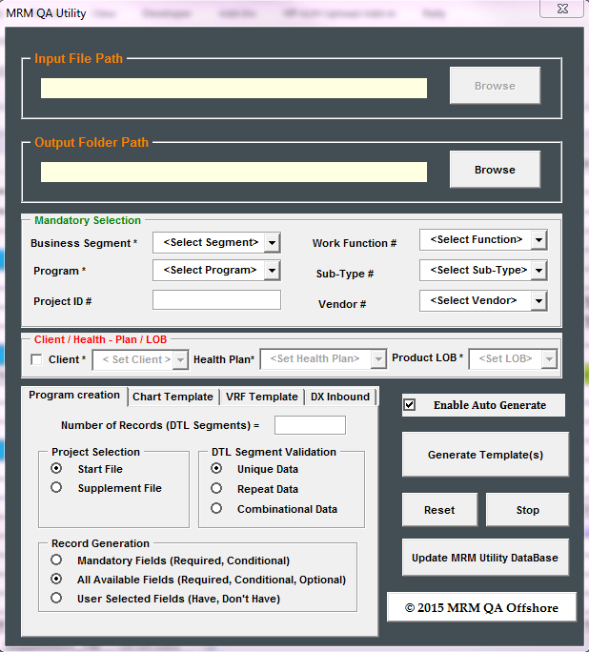

- Tabs :
There are several Tabs in utility. Each has its own purpose:
(i). Program Creation Tab is used to generate Start/ Supplement File
(a). CPC Program
(b). CRQS Program
(ii). Chart Template Tab is used to generate Images (.pdf Files)
(iii). VRF Template Tab is used to generate Vendor Response Files
(iv). DX Inbound Tab is used to generate DX Inbound Files.

- Enable Auto Generate :
When user enables this check box and clicks on Generate Template button, every time a new inbound file is created with random data.

- Generate Template(s) :
This button when clicked will generate the appropriate output file.

- Reset Data :
This button when clicked will reset all the buttons Checkboxes, Textboxes, Drop downs, Radio buttons to default.

- Stop :
This button when clicked will stop the utility and closes the pop-up on screen.

- © 2015 MRM QA Offshore :
If you have any queries / suggestions use this button.

- Settings :
Update the DB Details on the Sheet Named “Settings” as below:
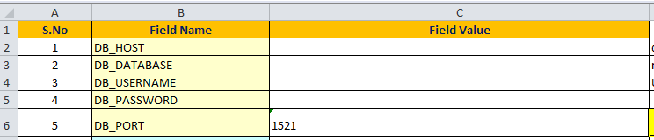

- Inbound Files :
Utility is supported to generate the below files as on today:

  - START File Generation:
START File can be generated based on the input in Excel sheet name Start_File.
User has provision to generate different data based on Mandatory, Optional, User Selected Fields

  - SUPPLEMENT File Generation :
SUPPLEMENT File can be generated based on the input in Excel sheet name Supplement_File.
User has provision to generate different data based on Mandatory, Optional, User Selected Fields

  - CHART File Generation :
Charts can be generated based on Project Id supplied on UI of the Tool

  - VENDOR RESPONSE File Generation :
Vendor Response File can be generated based on the input in Excel sheet name VRF Data
User has provision to generate different data based on Mandatory, Optional, User Selected Fields

  - DX Inbound File Generation :
DX Inbound File can be generated based on the input in Excel sheet name CR DX Data
User has provision to generate different data based on Mandatory, Optional, User Selected Fields

